✦ ✦ ✦
GLOBAL FASHION RETAIL
CAPSTONE PROJECT

SQL BUSINESS ANALYSIS REPORT
Ten Data-Driven Business Questions Answered Through SQL
Customer Behaviour · Sales Performance · Product & Store Analytics
✦ ✦ ✦

About This Report

This report presents a SQL-driven business analysis of a global fashion retail dataset, covering transactions, customers, products, and stores across multiple regions. Each section walks through a specific business question, the SQL logic used to answer it, and the resulting query output — providing a clear, end-to-end view of the analytical process from problem to insight.
Key Areas Covered
▪ 1. Customer Demographics Analysis
▪ 2. Sales vs Returns Trends
▪ 3. Top Performing Categories
▪ 4. Payment Method Performance
▪ 5. Promotion Impact Analysis
▪ 6. Customer Loyalty Tracking
▪ 7. Store Performance Ranking
▪ 8. Price Band Contribution
▪ 9. Basket Size Insights
▪ 10. Monthly Growth Trends

Table of Contents

About This Report 2
Table of Contents 3
SQL Business Questions
01 Customer Demographics Analysis 4
02 Sales vs Returns Trends 6
03 Top Performing Categories 8
04 Payment Method Performance 9
05 Promotion Impact Analysis 10
06 Customer Loyalty Tracking 11
07 Store Performance Ranking 13
08 Price Band Contribution 15
09 Basket Size Insights 16
10 Monthly Growth Trends 17

Question 01

Customer Demographics Analysis

Retrieve the number of unique customers by country and city along with their average purchase value.

▸ SQL QUERY
WITH invoice_summary AS (
SELECT
Invoice_ID,
Customer_ID,
MAX(Invoice_Total) AS Invoice_Total
FROM transactions
GROUP BY Invoice_ID, Customer_ID
)

SELECT
CASE
WHEN Country = '中国' THEN 'China'
ELSE Country
END AS Country,
City,
COUNT(DISTINCT customers.Customer_ID) AS Unique_Customers,
ROUND(AVG(invoice_summary.Invoice_Total), 2) AS Average_Purchase_Value
FROM customers
JOIN invoice_summary
ON customers.Customer_ID = invoice_summary.Customer_ID
GROUP BY Country, City
ORDER BY Average_Purchase_Value DESC;

▸ QUERY OUTPUT
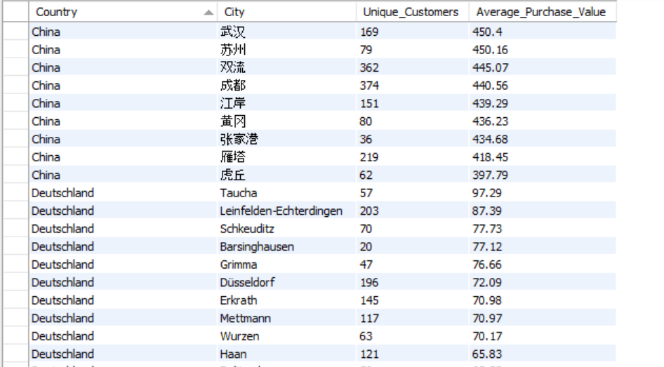

Question 02

Sales vs Returns Trends

Calculate the percentage of returns compared to total transactions and track how it changes monthly.
▸ SQL QUERY
WITH monthly_transactions AS (
SELECT
Invoice_ID,
DATE_FORMAT(Date, '%Y-%m') AS Month,
MAX(Transaction_Type) AS Transaction_Type
FROM transactions
GROUP BY Invoice_ID, DATE_FORMAT(Date, '%Y-%m')
)
SELECT
Month,
COUNT(*) AS Total_Transactions,
SUM(Transaction_Type = 'Return') AS Returned_Transactions,
ROUND((SUM(Transaction_Type = 'Return') * 100.0) / COUNT(*), 2) AS Return_Percentage
FROM monthly_transactions
GROUP BY Month
ORDER BY Month;
▸ QUERY OUTPUT
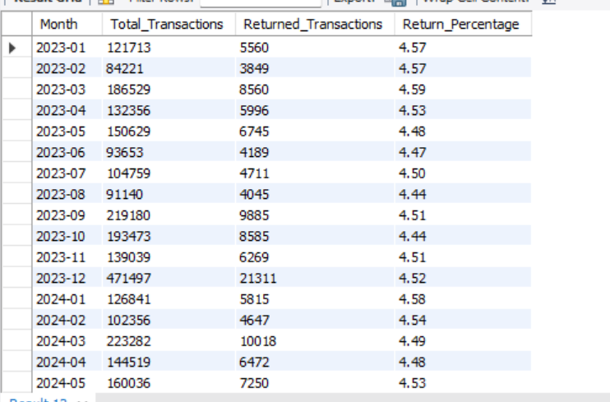

Question 03

Top Performing Categories

Identify the top categories by total revenue and their share in overall sales.
▸ SQL QUERY
WITH category_revenue AS (
SELECT
Category,
SUM(Line_Total) AS Total_Revenue
FROM products
JOIN transactions
ON products.Product_ID = transactions.Product_ID
GROUP BY Category
)

SELECT
Category,
Total_Revenue,
ROUND(
Total_Revenue * 100.0 /
(SELECT SUM(Total_Revenue) FROM category_revenue),
2
) AS Revenue_Share_Percentage
FROM category_revenue
ORDER BY Total_Revenue DESC;
▸ QUERY OUTPUT
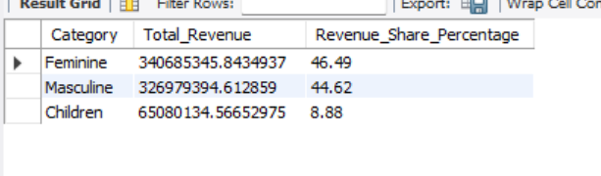

Question 04

Payment Method Performance

Compare total sales volume and average basket value across payment methods.
▸ SQL QUERY
WITH payment_summary AS (
SELECT
Invoice_ID,
Payment_Method,
MAX(Invoice_Total) AS Invoice_Total
FROM transactions
GROUP BY Invoice_ID, Payment_Method
)

SELECT
Payment_Method,
COUNT(Invoice_ID) AS Total_Sales_Volume,
ROUND(AVG(Invoice_Total), 2) AS Average_Basket_Value
FROM payment_summary
GROUP BY Payment_Method
ORDER BY Total_Sales_Volume DESC;
▸ QUERY OUTPUT
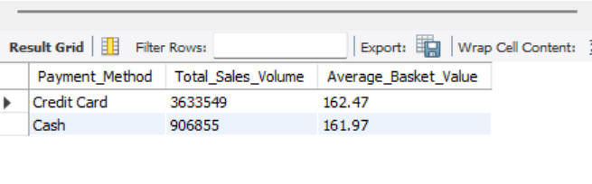

Question 05

Promotion Impact Analysis

Compare sales volume and revenue during discount periods versus non-discount periods.
▸ SQL QUERY
WITH invoice_discount AS (
SELECT
Invoice_ID,
CASE
WHEN MAX(Discount) > 0 THEN 'Discount Applied'
ELSE 'No Discount'
END AS Discount_Status,
MAX(Invoice_Total) AS Invoice_Total
FROM transactions
GROUP BY Invoice_ID
)

SELECT
Discount_Status,
COUNT(Invoice_ID) AS Sales_Volume,
ROUND(SUM(Invoice_Total), 2) AS Total_Revenue
FROM invoice_discount
GROUP BY Discount_Status
ORDER BY Total_Revenue DESC;
▸ QUERY OUTPUT
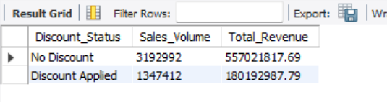

Question 06

Customer Loyalty Tracking

Measure the proportion of new versus repeat customers each month along with their average spend.
▸ SQL QUERY
WITH first_purchase AS (
SELECT
Customer_ID,
MIN(Date) AS First_Purchase_Date
FROM transactions
GROUP BY Customer_ID
),

invoice_summary AS (
SELECT
Invoice_ID,
Customer_ID,
DATE_FORMAT(Date, '%Y-%m') AS Month,
MAX(Date) AS Purchase_Date,
MAX(Invoice_Total) AS Invoice_Total
FROM transactions
GROUP BY Invoice_ID, Customer_ID, DATE_FORMAT(Date, '%Y-%m')
)

SELECT
Month,
CASE
WHEN Purchase_Date = First_Purchase_Date THEN 'New Customer'
ELSE 'Repeat Customer'
END AS Customer_Type,
COUNT(DISTINCT invoice_summary.Customer_ID) AS Customers,
ROUND(AVG(Invoice_Total), 2) AS Average_Spend
FROM invoice_summary
JOIN first_purchase
ON invoice_summary.Customer_ID = first_purchase.Customer_ID
GROUP BY Month, Customer_Type
ORDER BY Month;
▸ QUERY OUTPUT
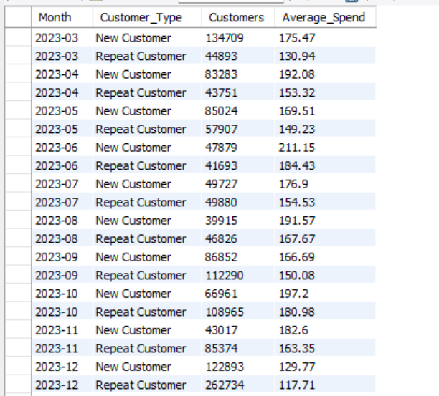

Question 07

Store Performance Ranking

Identify the top and bottom stores by revenue and return rates.
▸ SQL QUERY
SELECT
stores.Store_ID,
Store_Name,
ROUND(SUM(Line_Total), 2) AS Total_Revenue,
ROUND(
(SUM(Transaction_Type = 'Return') * 100.0) / COUNT(*),
2
) AS Return_Rate
FROM stores
JOIN transactions
ON stores.Store_ID = transactions.Store_ID
GROUP BY stores.Store_ID, Store_Name
ORDER BY Total_Revenue DESC;
▸ QUERY OUTPUT
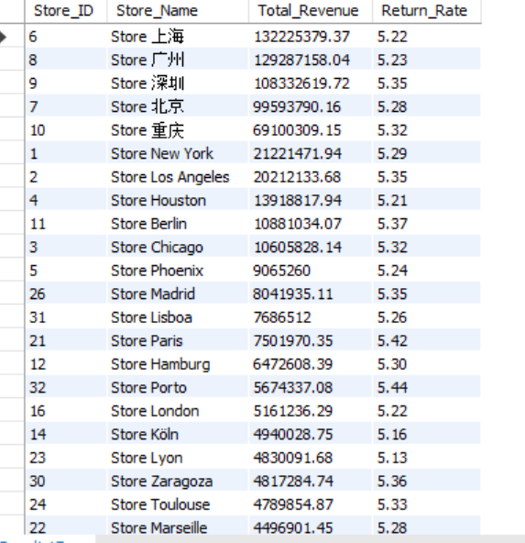

Question 08

Price Band Contribution

Segment products into price bands and analyze their contribution to total revenue and returns.
▸ SQL QUERY
WITH price_band_summary AS (
SELECT
CASE
WHEN Unit_Price < 50 THEN 'Below 50'
WHEN Unit_Price BETWEEN 50 AND 100 THEN '50-100'
WHEN Unit_Price BETWEEN 101 AND 200 THEN '101-200'
ELSE 'Above 200'
END AS Price_Band,
SUM(Line_Total) AS Total_Revenue,
SUM(Transaction_Type = 'Return') AS Total_Returns
FROM transactions
GROUP BY Price_Band
)

SELECT
Price_Band,
ROUND(Total_Revenue, 2) AS Total_Revenue,
ROUND(
Total_Revenue * 100 /
(SELECT SUM(Total_Revenue) FROM price_band_summary),
2
) AS Revenue_Contribution_Percentage,
Total_Returns
FROM price_band_summary
ORDER BY Total_Revenue DESC;
▸ QUERY OUTPUT
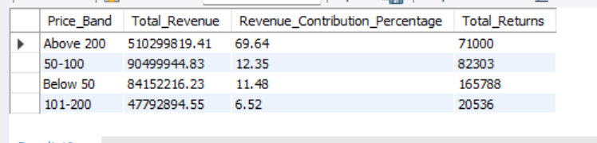

Question 09

Basket Size Insights

Calculate the average number of items and revenue per basket across different countries.
▸ SQL QUERY
WITH invoice_summary AS (
SELECT
Invoice_ID,
Customer_ID,
SUM(Quantity) AS Total_Items,
MAX(Invoice_Total) AS Invoice_Total
FROM transactions
GROUP BY Invoice_ID, Customer_ID
)

SELECT
Country,
ROUND(AVG(Total_Items), 2) AS Average_Items_Per_Basket,
ROUND(AVG(Invoice_Total), 2) AS Average_Revenue_Per_Basket
FROM customers
JOIN invoice_summary
ON customers.Customer_ID = invoice_summary.Customer_ID
GROUP BY Country
ORDER BY Average_Revenue_Per_Basket DESC;
▸ QUERY OUTPUT
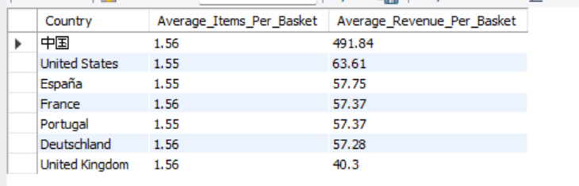

Question 10

Monthly Growth Trends

Analyze month-over-month revenue growth overall and for the top three categories.
▸ SQL QUERY
WITH top_categories AS (
SELECT
Category
FROM products
JOIN transactions
ON products.Product_ID = transactions.Product_ID
GROUP BY Category
ORDER BY SUM(Line_Total) DESC
LIMIT 3
),

monthly_revenue AS (
SELECT
DATE_FORMAT(Date, '%Y-%m') AS Month,
Category,
SUM(Line_Total) AS Monthly_Revenue
FROM products
JOIN transactions
ON products.Product_ID = transactions.Product_ID
WHERE Category IN (SELECT Category FROM top_categories)
GROUP BY DATE_FORMAT(Date, '%Y-%m'), Category
)

SELECT
Month,
Category,
ROUND(Monthly_Revenue, 2) AS Monthly_Revenue,
ROUND(
(Monthly_Revenue -
LAG(Monthly_Revenue) OVER (PARTITION BY Category ORDER BY Month))
* 100 /
LAG(Monthly_Revenue) OVER (PARTITION BY Category ORDER BY Month),
2
) AS Monthly_Growth_Percentage
FROM monthly_revenue
ORDER BY Month, Category;
▸ QUERY OUTPUT
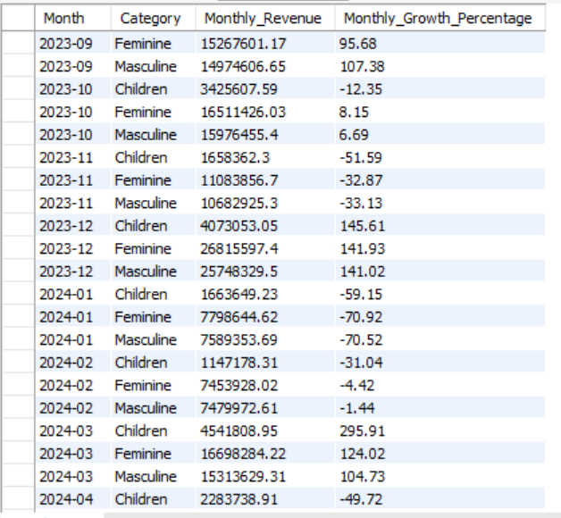

✦ ✦ ✦
End of Report
Global Fashion Retail Capstone Project — SQL Business Analysis Report
Prepared for academic submission and portfolio presentation

